RealTimeAudio Instructions

* Download RealTimeAudioV3.exe
* Before running the application, plug in your button into your computer’s 3.5mm jack
  + Some computers only have one, others have two
    - If your computer has two, plug it into the microphone jack
  + Often it will ask you what the device is, choose “Mic in”

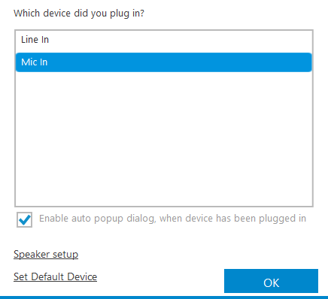

* Now you can run the application and a command window will pop up
  + Your computer may ask you to search for an app in the store
    - Select No, nothing else is needed
  + It will be black for a significant amount of time while it unpacks
  + It will then begin configuring to fit the specific computer which may take a second
  + Finally, it will ask to calibrate the button press, press the button and a graph should appear

